- Go to the below resource and update the $web folder or Use Azure Storage Explorer

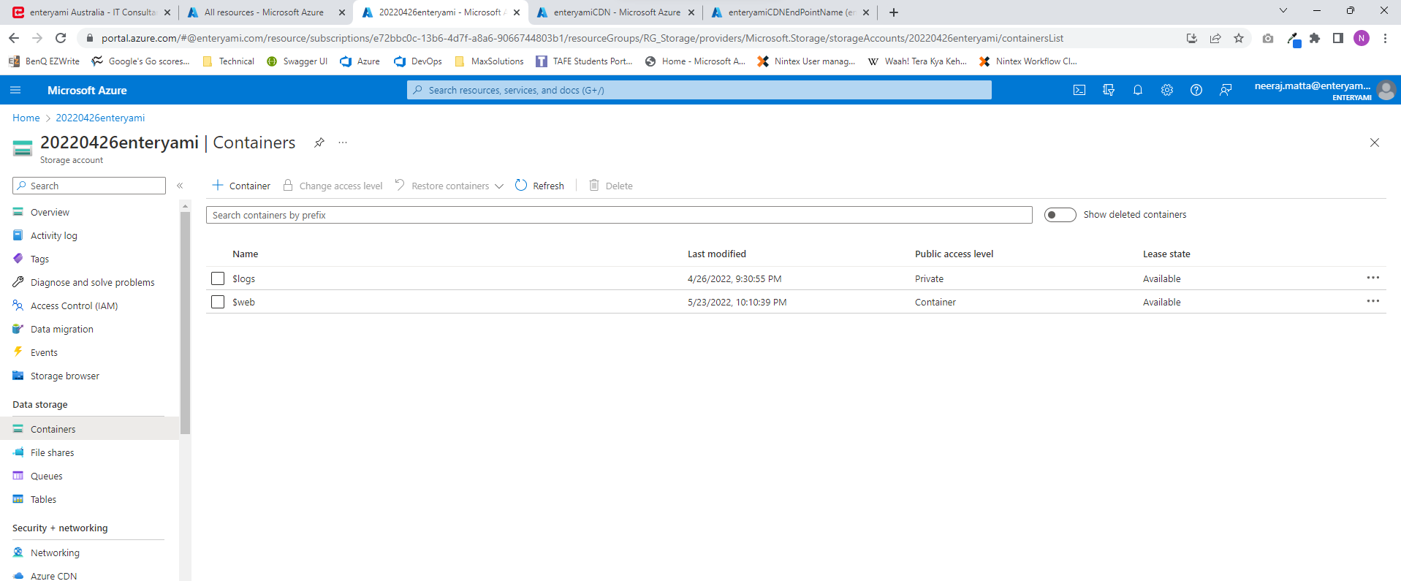

- Go to the below resource and “Purge”
